**Assignment 10.6**

**Problem Statement :**

1.Write a pig script to find the minimum temperature observed in a given weather station in a particular year.

2. Write a pig script to find the maximum temperature observed in a given weather station in a particular year.

3. Write a pig script to find the number of readings given by each weather station according to the dataset.

**Input:**

You can download the dataset from the below link:

<https://github.com/prateekATacadgild/DatasetsForCognizant/blob/master/Temperature.csv>

**Program:**

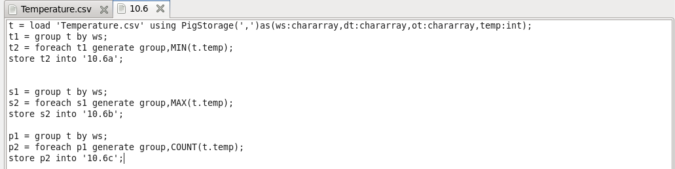

**Output:**

